TINYEPICGALAXIES

A microgame of galactic conquest

By Scott Almes

2-4 Players, 30 minutes

**Overview:**

Your home galaxy is overpopulated and your citizens are looking to the stars. It’s time for your empire to soar into the vast frontier above. You will grow your fleet, expand your influence, and colonize planets in the name of galactic conquest. But, you are not the only empire looking to expand. Opportunistic rivals from other systems are growing just as fast as you, and not even space is big enough for all your ambitions to come true. If you maneuver your fleet correctly, select the right planets, and outwit your opponents then you can control the galaxy, leaving your rivals floating on worthless space rocks.

**Objective:**

Galactic empires are competing to colonize newly discovered planets. Earn victory points by colonizing planets and increasing your galaxies’ level. Whoever has the most victory points at the end of the game wins!

**Components:**

* 4 Home Galaxy cards • 24 Planet cards

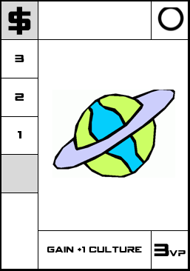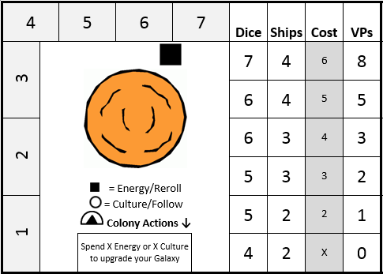

* 7 Action dice

|  |  |  |  |  |  |
| --- | --- | --- | --- | --- | --- |
| **↗** | [http://cdn.shopify.com/s/files/1/0080/8372/products/tattly_yoko_sakao_ohama_circle_web_design_01_grande.jpg?v=1370292941](http://www.google.com/url?sa=i&rct=j&q=&esrc=s&frm=1&source=images&cd=&cad=rja&uact=8&docid=nVTj1XFx2mvUmM&tbnid=_BYyfynanIR6NM:&ved=0CAUQjRw&url=http://tattly.com/products/circle&ei=lktZU73kILOK2QWzuoGgCw&bvm=bv.65397613,d.b2I&psig=AFQjCNG3gsBjNxHuA0QsV6F7DiqSTxZfRQ&ust=1398447379912534) |  | $ | ! |  |

* 1 Control Card
* 16 Ships (4 each in 4 colors)
* 4 Empire tokens (hexes)
* 4 Culture tokens (discs)
* 4 Energy tokens (cubes)

**Game Set-Up:**

1. Give each player a Home galaxy card. Place the others back into the box.
2. Give each player 4 Ships, 1 Culture disc, 1 Energy cube, and 1 Empire hex in their color.
3. Players start the game with 2 ships on their home galaxy. The other two are set aside.
4. Players keep track of their culture and energy levels by placing the corresponding tokens on the track around their home galaxy. Start the game with 1 culture and 2 energy.
5. Players keep track of their galaxy level by using the Empire token on the chart on their Home galaxy card. Start the game at the “x” spot on the cost column, this is level 1.
6. Shuffle the deck of Planet cards. Draw 2 more than the number of players and place each one face up in the center of the table. (For example, in a 3 player game, you would place 5 planets in the center.) These are newly discovered planets, ready for colonization.
7. Place the Control Card in the center of the table. Set the dice near the Control Card.

**Gameplay:**

Players take turns going clockwise until one player reaches 21 victory points. Play will continue back to the starting player (who will not take another turn). The player who most recently finished a science fiction book goes first.

**On Your Turn:**

Refer to the chart on your home galaxy card. Take the number of dice specified for your empire's influence level, and roll them.

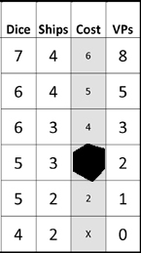

In this example, the player would roll 5 dice.

**Activating Dice / Control Card**

Activate the dice you wish to use in succession by placing them on the Control Card (to show that it has been activated) and completing the action shown on their die face. They can be activated in any order you wish, one at a time, but a die cannot be activated more than once in a turn. After you activate a die, there is a brief moment when other players may copy your action (See: Using Culture).

**Rerolling Dice**

At any point during your turn, you may reroll any number of your dice that have not yet been activated. The first reroll is free; thereafter, each reroll costs 1 energy. You do not have to activate all of your dice.

**Actions from Dice**

Each die face represents a unique action. They are:

**↗Move**

Move one of your ships from its current planet to another planet. When arriving at a planet, a ship can do one of two things:

1. **Land on the Planet's Surface**

If you land a ship on a planet's surface, you immediately get to perform the action listed at the bottom of the card. (In this example, the player would gain 1 culture.)

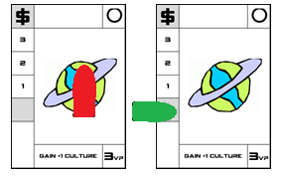

1. **Orbit the Planet and Prepare To Colonize**

If you choose to orbit the planet, place your ship on the starting position of the card's colonization track. The symbol at the end of the track, its influence icon, determines which action will allow you to move the ship further along the track: Diplomacy or Economy. The first player to reach the end of the track, influence icon, will colonize the planet.



More general movement rules:

* When you move, you must switch planets. You cannot move from the surface to the colonization track on the same planet, nor vice versa.
* On the colonization track, multiple players may have a ship on the same space.
* You can only have one ship per colonization track.
* Players cannot land more than 1 of their ships on the same planet surface, other than their home galaxy.
* Multiple players may land on the same planet surface.
* If at any point during the game your ship becomes displaced, it is returned to your home galaxy.

 **Energy**

Gain 1 energy for each ship you have on an energy planet (either on the colonization track or on the planet's surface). You cannot have more than 7 energy.

**[](http://www.google.com/url?sa=i&rct=j&q=&esrc=s&frm=1&source=images&cd=&cad=rja&uact=8&docid=nVTj1XFx2mvUmM&tbnid=_BYyfynanIR6NM:&ved=0CAUQjRw&url=http://tattly.com/products/circle&ei=lktZU73kILOK2QWzuoGgCw&bvm=bv.65397613,d.b2I&psig=AFQjCNG3gsBjNxHuA0QsV6F7DiqSTxZfRQ&ust=1398447379912534) Culture**

Gain 1 culture for each ship you have on a culture planet (either on the colonization track or on the planet's surface). You cannot have more than 7 culture.

! **Diplomacy**

For one of your ships on a colonization track ending with the "!" symbol, advance the ship to the next space. If you reach the end of the track, the influence icon, you have colonized the planet. All ships on the card are returned to their owner's home galaxy. Take the planet card and slide it under your home galaxy card so that the action and victory points are still visible. That action is now available whenever you activate a Colony die. Announce your new victory point total. **A new planet card is drawn immediately to replace the colonized planet.**

$ **Economy**

This is identical to the Diplomacy action except that it applies to colonization tracks ending with the "$" symbol.

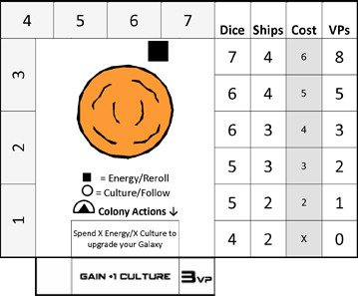

(*An example of a home galaxy card with a planet that’s been colonized*)

 **Colony**

Activating a colony die allows you to perform any one action from your colonized planets.

Default Colony Action: Upgrade your Galaxy

All home galaxies start with the colony action “Upgrade your Galaxy.” To upgrade your galaxy, spend the amount of energy or culture of the next level’s "cost" listed on the cost chart on your home galaxy. This cost must be paid entirely in energy or entirely in culture; they cannot be combined. (For example, to move to the third space, Influence 3, you need to spend either 3 energy or 3 culture.) Increasing your empire's influence increases your victory points. Announce your new victory point total.

Depending on the level, you will also gain a ship or another die. If you gain a ship, immediately place it on your home galaxy. If you gain another die, it will be available to you at the start of your next turn.

**Using the Converter**

The converter is used to turn a die to a face of the player’s choice. To use the convert, place any two dice into the two slots in the converter, then change the face of another die to the face of your choice. The dice in the converter slots cannot be used by the active player, nor can they be followed by another player (See: Using Culture).

**Finishing Your Turn:**

Once you have activated all of your dice, your turn is over. Players have a chance to follow the last die. Then, play passes to the next player in the clockwise direction.

**On Another Player's Turn:**

**Using Culture to Follow**

After a player has locked a die, each player has a brief moment to decide whether they want to follow that action. To follow, a player must spend a culture and then they get to copy that die’s action. Each die can only be followed once per player. Any timing disputes should be resolved by the players following clockwise, starting from the player to the left of the active player.

**Winning:**

Once a player reaches 21 points, the end of the game is triggered. After that occurs, continue play until it gets back to the starting player (who does not take another turn). The player with the most points wins! Ties are broken first by number of planets colonized, then by level of galaxy, if still tied, total number of combined resources is the final tie breaker.